DOCUMENTATION

ASSIGNMENT 1 – DISTRIBUTED SYSTEMS

STUDENT: ANDREEA-LAVINIA GAVRILESCU
GROUP: 30242

CUPRINS

1. The objective of the theme 3
2. Problem analysis, modeling, scenarios, use cases 3
3. Design 3
4. Implementation 3
5. Results 3
6. Conclusions 3
7. Bibliography 3

The objective of the theme

Main obejective
- Develop an Energy Management System that consists of a frontend part and two microservices designed to manage devices, users and their aasociated smart energy metering devices. The system can be accessed by two types of users: admins and clients. The administrator can perform CRUD operations on both users and devices and also on the mapping between them. The client can only see his/her devices.

Secondary objectives
- Problem analysis and requirements identification
- Designing the microservices and an associated frontend
- Implementation the microservices and an associated frontend
- Testing the both of the microservices and the frontend

Aproblem analysis, modeling, scenarios, use cases

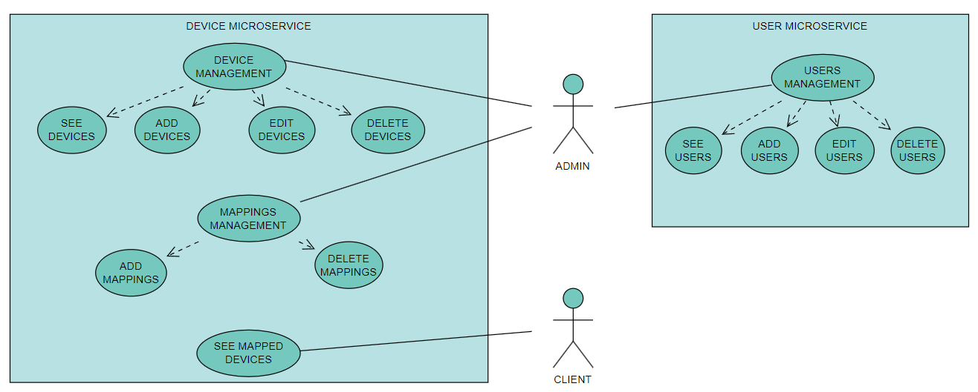

Functional requirements
- The user microservice should provide secure authentication.
- The user microservice should allow an administrator to perform CRUD operations on user accounts.
- The user microservice should restrict admin options from client options and viceversa.
- The user microservice should update the list of users available for mapping when performing a change on a user account.
- The device microservice should allow an administrator to perform CRUD operations on user accounts.
- The device microservice should allow an administrator to add and delete mappings between users and devices.
- The frontend should allow the users to perform their actions.
- The frontend should not allow users to access pages where they do not have permission.
- The final application with all the modules should be deployed on Docker.

Non-functional requirements
- The frontend should be interactive and easy to use

Cazuri de utilizare
- Use case 1: login
Actor: administrator/client
Main scenario
- The user needs to enter valid credentials in the form and press the SIGN IN button.
- The user will be redirected to the next page according to the user role.
Alternative scenario
- The user can introduce wrong credentials.
- The scenario goes back to step 1.

- Use case 2: see the list of users / see the list of devices / see the list of mappings
Actor: administrator
Main scenario
- The administrator needs to go to the User Management / Device Management / Mappings Management page.
- The administrator can see the users / devices / mapping and information about them in the form of a table.

- Use case 3: add a new user/ add new device
Actor: administrator
Main scenario
- The administrator needs to go to the User Management / Device Management page.
- The administrator needs to press the ADD USER / ADD DEVICE button.
- The administrator needs to complete the form that opens with correct information.
Alternative scenario
- The administrator could introduce wrong details.
- The scenario goes to step 3.

- Use case 4: edit an user/ edit a device
Actor: administrator
Main scenario
- The administrator needs to go to the User Management / Device Management page.
- The administrator needs to press the EDIT button.
- The administrator needs to edit the wanted field in the form that opens with correct information.
Alternative scenario
- The administrator could introduce wrong details.
- The scenario goes to step 3.

- Use case 5: delete an user/ delete a device
Actor: administrator
Main scenario
- The administrator needs to go to the User Management / Device Management page.
- The administrator needs to press the DELETE button.
- The administrator needs to confirm the wish to delete an user / device in the pop-up that will appear after pressing the delete button.
Alternative scenario
- The administrator could press no on the cofirmation pop-up.
- The scenario goes to step 3.

- Use case 6: add mapping
Actor: administrator
Main scenario
- The administrator needs to go to the Mapping Management page.
- The administrator needs to press the ADD MAPPING button that will redirect him/her to the Add Mappings page.
- The administrator needs to select an user and a device and then press the ADD MAPPING button.
Alternative scenario
- The administrator could select more than one user or device.
- The scenario goes to step 3.

- Use case 6: delete an user/ delete a device
Actor: administrator
Main scenario
- The administrator needs to go to the Mappings Management page.
- The administrator needs to press the DELETE button.
- The administrator needs to confirm the wish to delete a mapping in the pop-up that will appear after pressing the delete button.
Alternative scenario
- The administrator could press no on the cofirmation pop-up.
- The scenario goes to step 3.

- Use case 7: see mapped devices
Actor: client
Main scenario
- The client needs to login to his/her account successfully.
- The client will be redirected to the page where he/she can see all of his/her devices.
Alternative scenario
- The client could enter wrong credentials in the login form.
- The scenario goes to step 1.

Design

Architecture Diagram
- I will follow a layered architecture, because it separates the application into distinct layers, each responsible for specific functionalities so that a change in one layer doesn't necessarily require modifications in the others.

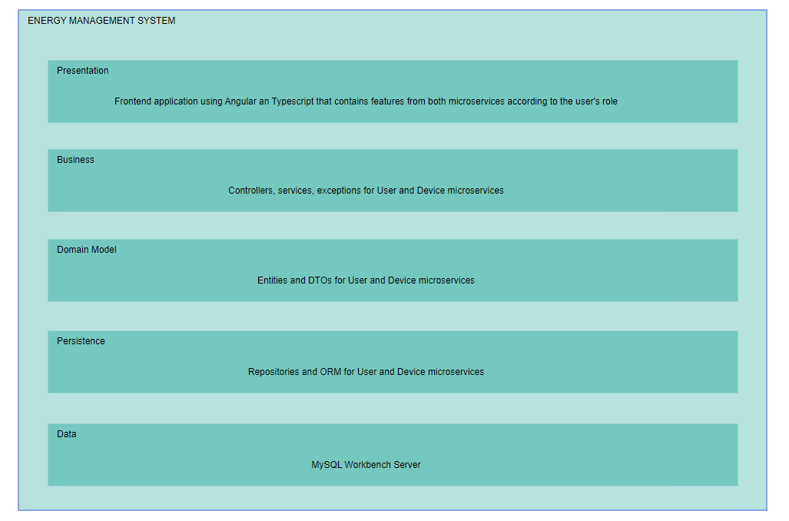

Package division
- Backend packages: domain(entity, dto), repository, service, exception, controller, security and utils (only for User microservice)

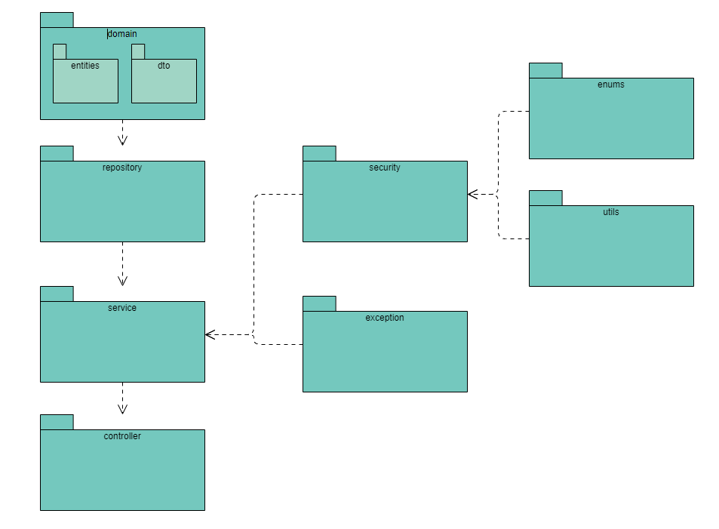
- Frontend structured in the following components: login, navbar, admin-menu, user-options, device-options, mapping options, user-devices
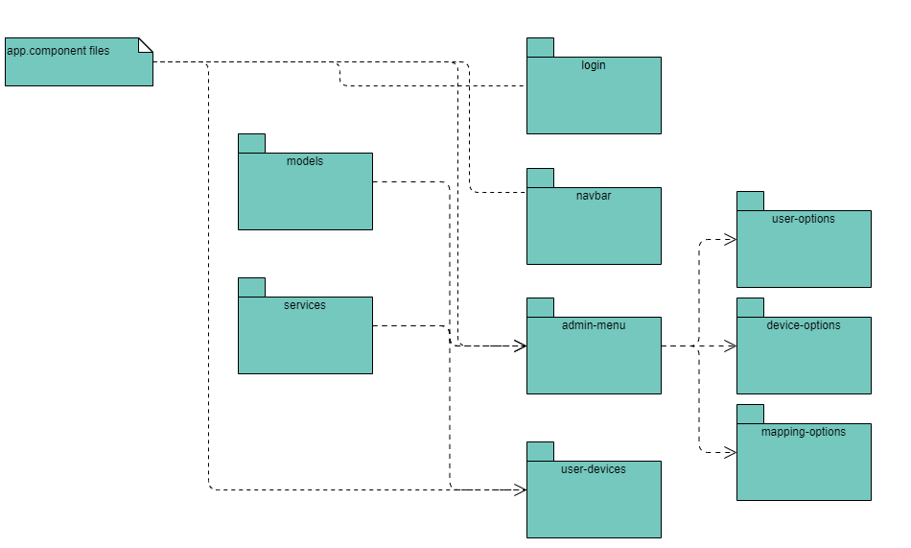

Implementation
For the backend I chose to use Java and Spring as framework.
For the database, I used MySQLWorkbench and Hibernate in order to create tables from my backend applications.
User Microservice
- Database
- In this DB there is only an users table that has the following columns: user_id, name, email, password, role.
- Login and security
- For this part I used spring security, more exactly using a JWT token from which I can identify the role of the user and redirect he/she to the corresponding page on frontend.
- CRUD operations and calls to the other microservice
- I implemented this operations in order to be able to see / add / edit or delete an user.
- What is important is that everytime a change is performed on an user account, it should make a call to the Device microservice in order to update the additional table of users from its DB.
- I implemented two methods in order to achive this: one for adding the user cretead / updated in the users_available table and one to delete the user from the same table. After making this calls, the user will be added / updated or delete from the users table.
- Here is one of the methods that will be called when performin CRUD operations:

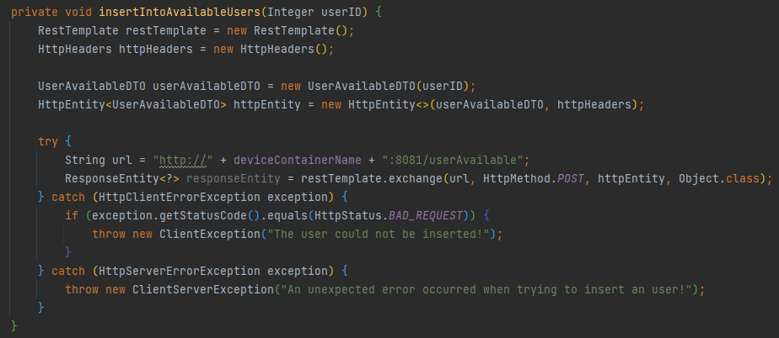

Device Microservice
- Database
- In this DB there are two tables: devices(device_id, address, consumption, description, user_id) and users_available(user_id).
- user_id is foreign key because we will need it when we add or delete a mapping.
- CRUD operations for device and mapping
- I implemented this operations in order to be able to see / add / edit or delete an device.
- Also here is where I perform the add and delete operations for mappings.
- When I add a mapping, I basically set the user_id in the devices tables which is intially null with the id of the user for which an administrator added a mapping.
- For deleting a mapping, I choose to set the user_id to null.

Frontend
- I implemented it using Typescript and Angular as framework. It is structered in components that communicate with each other.
- I intercepted the responses from the backend in the services and then used those methods in my components.
- The user will be redirected to the corresponding page according to its role which I identify from its authorization token.

Docker
- For the deployment of the application I created:
- Two volumes for the DBs and then two containers for the User DB and Device DB.
- A container for each microservice and the frontend application.
- I needed some configurations in my application.yml and then a Dockerfile for each module.
- After creating images and containers from them, my application is hosted on docker now, I only need to start the containers.
Deployment diagram
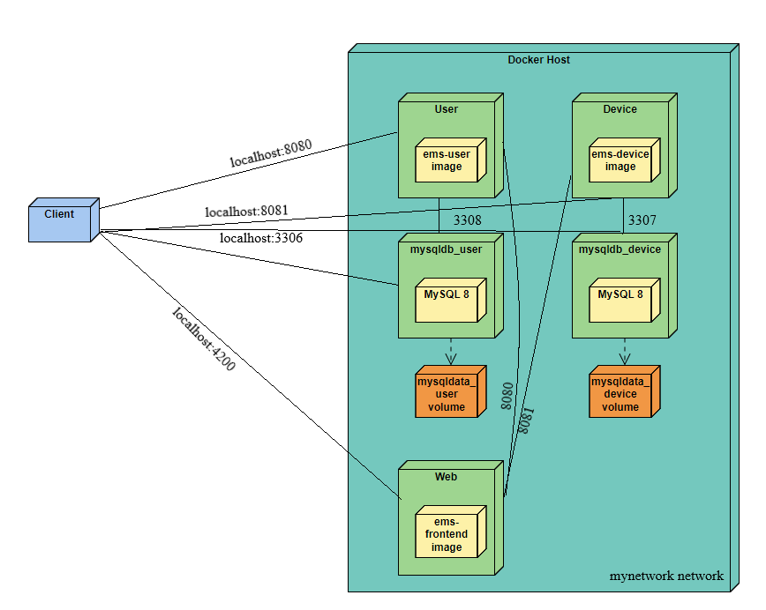

Results
For the testing part I used validation testing, meaning that I tested all the flows following the use-cases and verified if the changes are performed on the DB too.

Conclusions
In this assignment I got the chance to learn about deployment on Docker which I hopefully apply to my license. I also learned how to implement a communication mechanism between two microservices.

Bibliography
- https://docs.docker.com/language/java/deploy/
- https://medium.com/geekculture/how-to-create-and-deploy-docker-applications-1b00e4246c1d
- https://www.baeldung.com/rest-template
- https://www.geeksforgeeks.org/spring-resttemplate/

